Ex.No:18 - MATLAB SIMULATION AND EVALUATION OF EYE DIAGRAM PARAMETERS UNDER INTER-SYMBOL INTERFERENCE IN DIGITAL COMMUNICATION SYSTEMS

Objective 1:
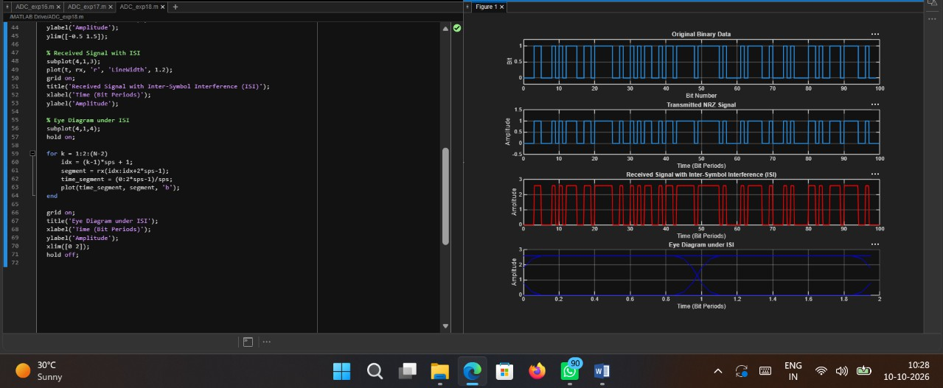
Code:
clc; clear; close all;
%% Parameters
N = 100; % Number of bits
sps = 20; % Samples per symbol
%% Generate Random Binary Data data = randi([0 1], 1, N);

%% NRZ Encoding
tx = repelem(data, sps);
%% Time Axis

t = (0:length(tx)-1)/sps;

%% Introduce Inter-Symbol Interference (ISI)
% Simple Low-Pass FIR Channel h = [0.2 0.6 1 0.6 0.2];
% Received Signal with ISI rx = conv(tx, h, 'same');

%% Plot Results figure;

% Original Binary Data subplot(4,1,1);
stairs(0:N-1, data, 'LineWidth', 1.5); grid on;
title('Original Binary Data'); xlabel('Bit Number'); ylabel('Bit');
ylim([-0.2 1.2]);

% Transmitted NRZ Signal subplot(4,1,2);
plot(t, tx, 'LineWidth', 1.5); grid on;
title('Transmitted NRZ Signal'); xlabel('Time (Bit Periods)'); ylabel('Amplitude');
ylim([-0.5 1.5]);
% Received Signal with ISI subplot(4,1,3);
plot(t, rx, 'r', 'LineWidth', 1.2); grid on;
title('Received Signal with Inter-Symbol Interference (ISI)'); xlabel('Time (Bit Periods)');
ylabel('Amplitude');
% Eye Diagram under ISI subplot(4,1,4);
hold on;

for k = 1:2:(N-2)
idx = (k-1)*sps + 1;
segment = rx(idx:idx+2*sps-1); time_segment = (0:2*sps-1)/sps; plot(time_segment, segment, 'b');
end
grid on;
title('Eye Diagram under ISI'); xlabel('Time (Bit Periods)'); ylabel('Amplitude');
xlim([0 2]); hold off;

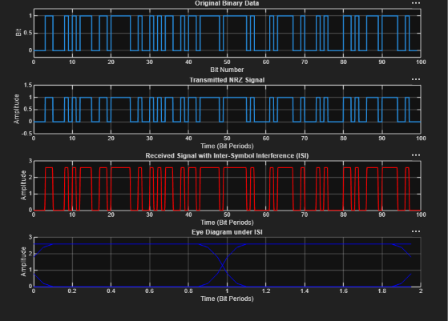
Output:

